System Configurations

Real Time
Adaptive Control & Monitoring (ACM)
Systems
for
CNC Metal Cutting Optimization

July 2004

ACM Configurations
Depending on the machine tool and CNC type, Omative ACM may be available in the following configurations:
Add-on: | In this configuration, the ACM system is a separate microprocessor-based unit (referred to as an ACM Unit) with its own LCD and Keypad. This version can connect to virtually any existing CNC machine. The following are examples of current installations:
  - Allen Bradley  - Fadal  - Fagor  - Fanuc 0, 6, 9, 10, 11, 12, 15, 16, 18  - Fidia  - Haas  - Heidenhain TNC 355, 407, 410, 415, 425, 426  - Heller Uni-Pro  - Hitachi Seiki Seicos  - Hurco UltiMax  - Mitsubishi | - Moric (Fanuc) M4F, M6F  - NUM  - Okuma  - Olivetti  - OSAI  - Philips  - Selca  - Siemens Sinumerik  - Tosnuc  - Toyoda  - Vickers Acramatic  - Yasnac
CNC-integrated: | These are Windows based versions developed for integration into specific CNCs such as:  - Siemens Sinumerik 810D and 840D  - DMG MillPlus  - Heidenhain iTNC 530  - Fidia X-Power  - and more

CNC-integrated Versions

ACM for Sinumerik – (Pure Software)
The system configuration consists of the following components:
- Real-time ACM software in the form of a ELF-file.
- Windows based Graphic User Interface used to initialize, configure and monitor the Adaptive Control and Monitoring function.
- Siemens Compile Cycle IACT.
- Sinumerik 840D base system.

The following are the Sinumerik 840D CNC attributes required in order to install this version:
Component | Requirement | Remarks
Drive hardware | Drive system based on SIMODRIVE 611D | Digital drive provides digital current, power and torque information.
PC hardware | SINUMERIK 840D PCU50
Control hardware | NCU572.x or NCU573.x | The NCU acts as an interface between the drive system and the Omative ACM and provides access to the current, torque and active power information of the digital drive system
Control software | SINUMERIK 840D NCK software version 06.05.11 or higher | An upgrade from the previous versions of NCK software may be ordered from Siemens. In case of an upgrade from NCK software version 06.03.xx or earlier, a PLC modification is also required.
HMI software | SINUMERIK 840D HMI software version 06.03.15 or higher | If the version of HMI software is earlier than 06.03, a different ELF-files flashing procedure will have to be applied.
Additional software | The Siemens Base Compile Cycle “Integrated Adaptive Control Technology (IACT)” as ELF-file | License to use the compile cycle “Integrated Adaptive Control Technology (IACT)”.  Note: The Siemens Compile Cycle IACT cannot be loaded into export-restricted versions!

ACM for Sinumerik – (Hardware & Software)
In this Sinumerik 810D/840D compatible version, Omative’s ACM Control Unit is connected to the CNC, while its user interface is integrated into the Sinumerik HMI.
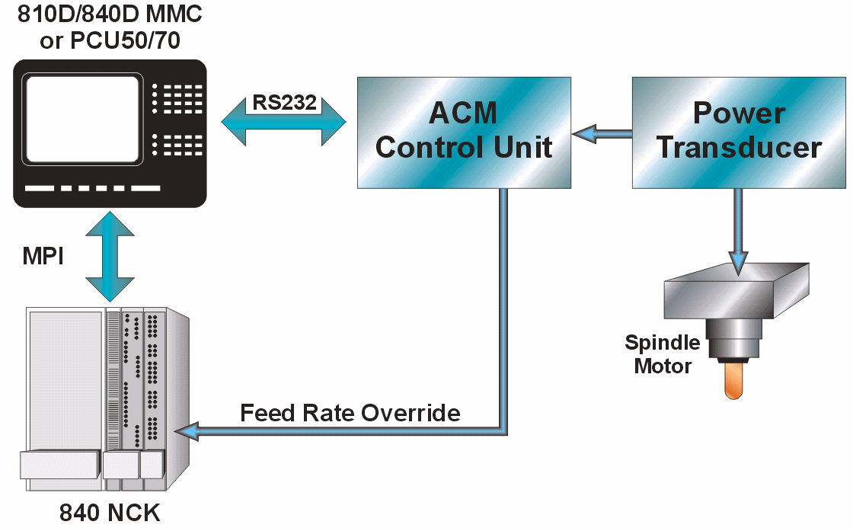
This configuration consists of:
- ACM Control Unit – connects from its digital outputs to the NCU, and from its analog inputs to the Omative Power Transducer Module (PTM). The ACM Control Unit measures the spindle power and communicates with the SINUMERIK’s PC through the SINUMERIK RS232 port.
- ACM real-time software – integrated into a microcontroller on the ACM Control unit.
- ACM user interface – A Windows Graphic User Interface application that is used to configure and monitor the Adaptive Control and Monitoring functionality.
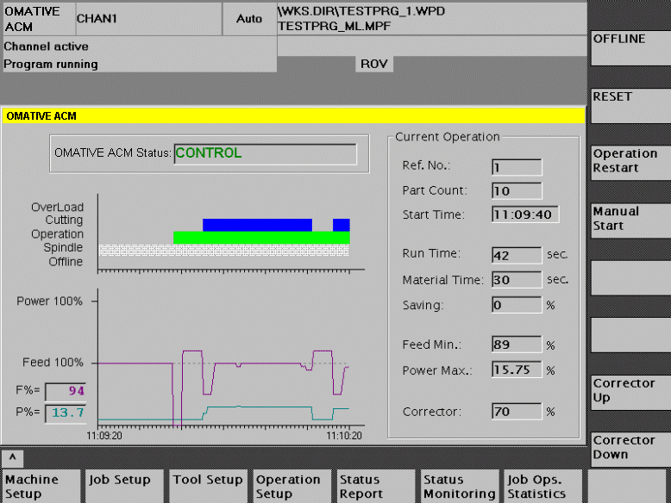

The following are the Sinumerik 810D and 840D CNC attributes required in order to install this version:
Component | Requirement | Remarks
Drive hardware | Any drive system | There are no drive system requirements since Omative PTM provides the spindle power data.
PC hardware | SINUMERIK 810D/840D PCU50/70 or MMC103
PC operating system | Windows 95, NT, XP
Control hardware | SINUMERIK 810D/840D, any NCU.  Min. Memory: 32MB | There are no special requirements for the NCU hardware version.
Control software | Any SINUMERIK 810D/840D NCU System Software | There are no CNC software requirements since the Compile Cycle Technological Function is not used.
HMI software | Versions: 3.7, 4.3, 4.4, 5.1, 5.2 or higher
Software options | Not required

ACM for DMG MillPlus
On DMG machines running under the MillPlus CNC, Omative ACM is a software product requiring no additional hardware.
ACM for DMG MillPlus consists of:
- Real-time software which is loaded into the MillPlus IT.
- A Windows Graphic User Interface application.
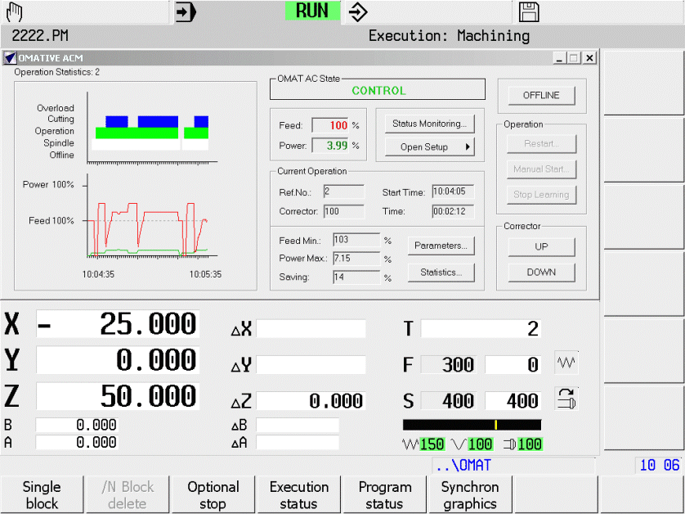

The following are the MillPlus CNC attributes required in order to install this version:
Component | Requirement
CNC hardware | MillPlus IT-DoubleProcessor (DP)
CNC operating system | MillPlus-IT V5.10 and up

Each product package requires a unique OMAT product key that must match the CNC SIK number.

ACM for Heidenhain iTNC
On machines running under the Heidenhain iTNC530, Omative ACM option is a software product requiring no additional hardware.

ACM for Heidenhain iTNC consists of:
- Real-time controller code which is linked to (or downloaded into) the iTNC software
- A Windows Graphic User Interface application.

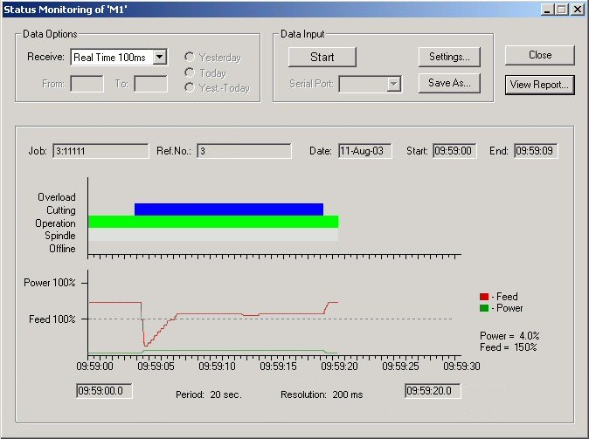
The following are the Heidenhain CNC attributes required in order to install this version:
Component | Requirement
CNC hardware | Heidenhain iTNC530
CNC operating system | software with ID numbers 340480 or 340422 or higher but not on the export versions (340423, 340481)

Each product package requires a unique OMAT product key that must match the CNC SIK number.

ACM for Fidia CNC
On machines running under the Fidia X-Power CNC, Omative ACM option is a combination of software and hardware.
The Omative ACM option for Fidia consists of:
- ACM Control Unit – connects from its digital outputs to the NCU, and from its analog inputs to the Omative Power Transducer Module (PTM). It is a real-time mechanism which measures spindle power and communicates with the Fidia’s PC through the Fidia RS232 port.
- ACM software – integrated into a microcontroller on the ACM Control unit.
- ACM user interface – A Windows Graphic User Interface application that is used to configure and monitor the Adaptive Control and Monitoring functionality.

The following are the Fidia CNC attributes required in order to install this version:
Component | Requirement
CNC operating system | Windows XP or NT
Control hardware | Fidia X-Power
Control software | Fidia CNC Software release 3.3.0 or higher

ACM Integration for other PC-based CNCs
Another alternative for integrating Omative ACM into a CNC can be accomplished by using Omative’s ACM Control Unit. This unit is electrically connected to the CNC as a black box (not usually accessible to the end user) and the user interface is integrated into a PC. Depending on the CNC’s software configuration, the User Interface may be implemented into the CNC.
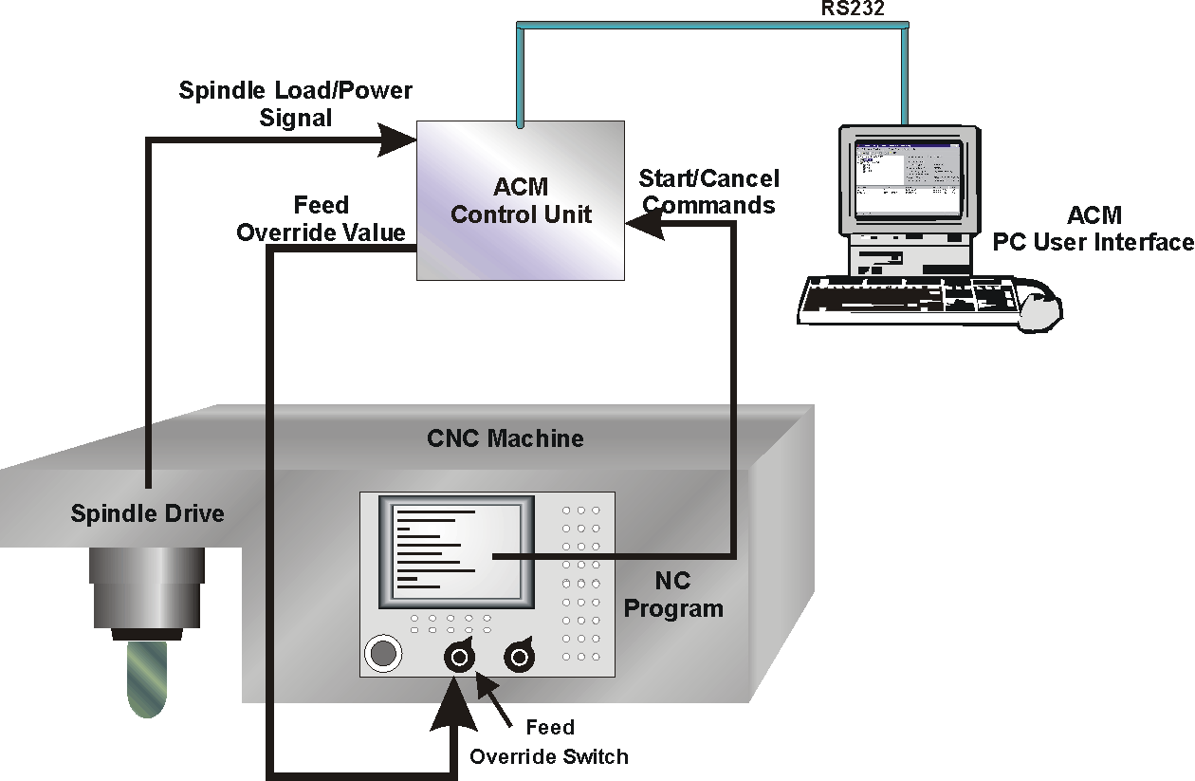

The following are the CNC attributes required in order to integrate Omative ACM:
Component | Requirement | Remarks
CNC Operating System | Windows 95/98/ME/2000/NT/XP
Feed rate override | Switch, potentiometer or pushbutton | The upper limit of the feed override should be greater than 100%
Output mechanism for tool referencing | A minimum of one unassigned M-function hardware output  or  The ability to output ASCII characters from the NC program through the RS-232 serial port during NC program execution
Lathe spindle drive | Availability of a spindle drive Speed Monitoring output signal | for turning machines only

ACM Add-on Version
The add-on version of ACM is a separate microprocessor-based unit (referred to as an ACM Unit) with its own LCD and Keypad. The ACM Unit can connect to virtually any existing CNC machine. The system is attached to the CNC operating console and connected to the CNC machine through the following signals:
- Spindle load/power signal from the machine spindle drive. OMATIVE proprietary Power Transducer may be installed to ensure that the signal is a true representative of the active spindle power.
- Feed Override signal to the CNC in order to control the feed rate
- Start/Cancel signals from the CNC (initiated by the NC program) in order to reference the indexed tool in real time
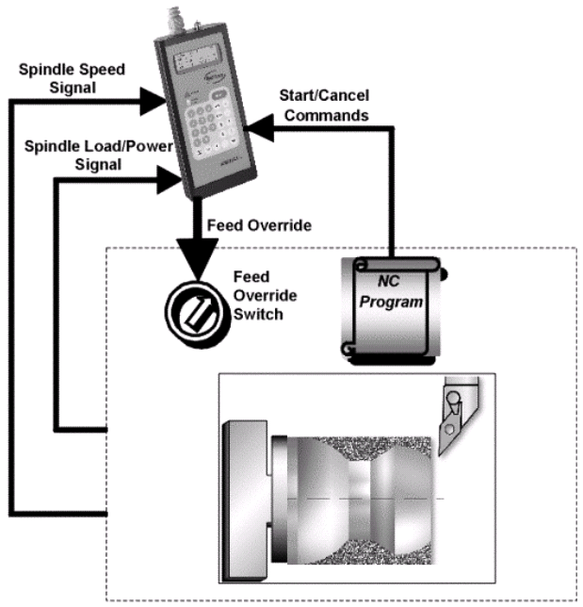
- Spindle speed monitoring signal (only from lathes) to enable a true representation of actual power as the cutting diameter varies

The installation is carried out by OMATIVE qualified representatives and does not require any machine modifications. Subsequent to the installation, a one-time calibration procedure is carried out to adapt the system to its specific machine environment.

The following machine configurations are required to install an Omative ACM add-on version:
- A feed rate override switch, potentiometer or pushbutton (the upper limit of the feed rate override control should be greater than 100%).
- A minimum of one unassigned M-function hardware output or The option to output ASCII characters from the NC program through the RS-232 serial port during NC program execution.
- A spindle drive Speed Monitoring output signal (for turning machines only).

ACM in the Machine shop

Opti-Pilot
In all their configurations, Omative ACM systems are supplied with a windows based software component - Opti-Pilot.
In the versions with PC-based user interface, Opti-Pilot features are integrated into the ACM system.
In the add-on version, Opti-Pilot software has to be installed on a PC connected to the ACM system via its RS232 port designated for external data communications.
Opti-Pilot may be used in conjunction with a single ACM system on one machine.

Omative-Pro Productivity Management System
All versions of Omative ACM systems can be integrated into a PC network running the optional Omative-Pro Productivity Management System.
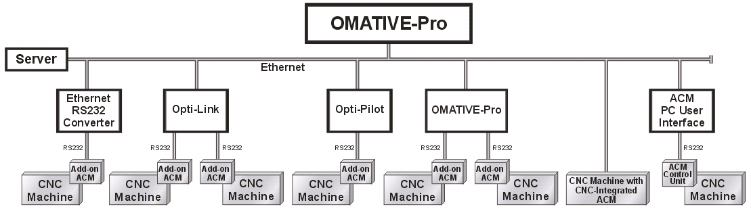
Configuration of Omative-Pro and ACMs in the Machine Shop

In any machine shop network, CNC machines equipped with ACM systems in various configurations may be clustered under Omative-Pro software.

